TYPE THE TITLE HERE

First AUTHOR ^{a,*}, Second AUTHOR ^{b}, Third AUTHOR ^{c}

ª Type the address here
^{b} Type the address here
^{c} Type the address here

*Corresponding author. Tel.: +90……. (type the telephone number here)
E-mail address: ……………… (e-mail here) (type the name of the corresponding author here, for example J. Smith for John Smith)
ABSTRACT
Type here (Abstract should not exceed 350 words)
Keywords: Type here (Each word must be separated by semicolons)
- Introduction
Type here (In-text citation examples should be as follows: (Smith, 2020; Smith et al., 2020; Smith & Johnson, 2020)

- Materials and methods
  - Subtitle 1
Type here ….
  - Subtitle 2
Type here ….
  - Subtitle 3
Type here ….

- Results and discussion
  - Subtitle 1
Type here ….
  - Subtitle 2
Type here ….
  - Subtitle 3
Type here ….
4. Conclusions
Type here ….
Acknowledgement
If any
Conflict of interest
The authors confirm that there are no known conflicts of interest.
(Or, if there is any conflict of interest, it should be stated)
Statement of ethics
In this study, no method requiring the permission of the “Ethics Committee” was used.
(Or, if a study was carried out requiring an ethics committee decision, the name of the committee, the date and number of the report should be stated)
Availability of data and materials
For example; all data generated or analyzed during this study are included in this published article.
Funding
None.
(Or, This study was financially supported by XYZ University Research Foundation, Project No. XXXXXXX).
CRediT authorship contribution statement
Author 1: Such as; Conceptualization, Investigation, Data curation, Writing - original draft, Supervision.
Author 2: Such as; Resources, Conceptualization, Visualization, Formal analysis, Investigation, Methodology.
Author 3: Such as; Resources, Formal analysis, Investigation.
ORCID Numbers of the Authors
Author 1 (J. Smith for John Smith): XXXX-XXXX-XXXX-XXXX
Author 2 (J. Smith for John Smith): XXXX-XXXX-XXXX-XXXX
Author 3 (J. Smith for John Smith): XXXX-XXXX-XXXX-XXXX
Supplementary File
……….

References
Type the references here
For example;
Bahadori, M. B., Kirkan, B., Sarikurkcu, C., & Ceylan, O. (2019). Metabolite profiling and health benefits of Stachys cretica subsp. mersinaea as a medicinal food. Industrial Crops and Products, 131(2), 85-89.

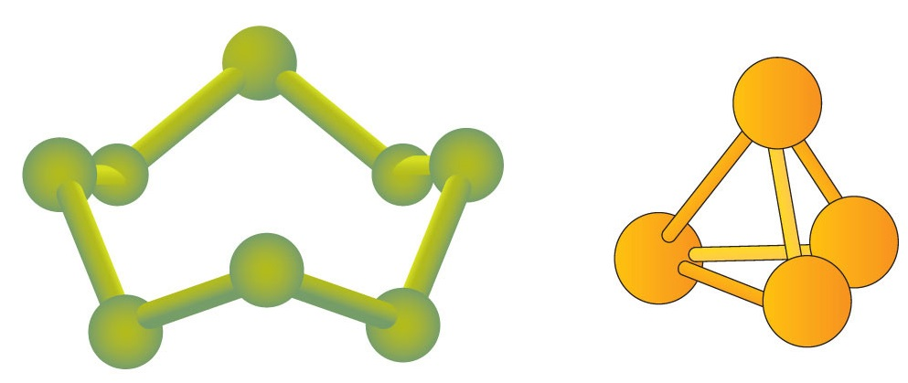
Figure 1. Type the title of figure here
Type the footnotes (if available)
Table 1. Type the title here ¹
XXXXX | XXXXXX | XXXXXX
Xxxxxxx | …………ª | …………
Xxxxxxx | …………^{b} | …………
Xxxxxxx | …………^{c} | …………
¹ Type the meaning of superscript lettering here
ª Type the meaning of superscript lettering here
^{b} Type the meaning of superscript lettering here
^{c} Type the meaning of superscript lettering here

